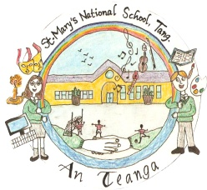
SCHOOL CALENDAR
September 2016 - June 2017

September 1st – June 27th

School Opens | Thursday, September 1st 2016
Halloween Break | October 31st – November 4th  (Inclusive)
Christmas  Holidays | School will close  Thursday 22nd December at 12pm.  School re-opens  January 9th, 2017.
Midterm Break | February 23rd & 24th
Bank Holiday | Friday, March 17th
Easter Holidays  2017  *** | School will close  Friday, 7th April @12pm.  School re-opens  Monday 24th April.
May  Bank Holiday | Closed  May 1st 2017.
June  Bank Holiday  Weekend | Closed  June 5th 2017.
Summer Holidays | School will close for summer holidays on Tuesday 27th June at 12pm.

There will be a planning day during the year for the new Primary Language Curriculum for which the school will close. These dates have not been provided yet but we will give plenty of notice.

*** Please note: If school has to close due to bad weather conditions, we have to make up days missed from Easter Holiday time.
*** Please note: If school has to close due to bad weather conditions, we have to make up days missed from Easter Holiday time.

