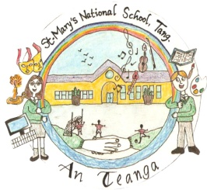
BOOK RENTAL PROCEDURE

Tang N.S.

Roll Number 08037Q

Tang NS operates a Book Rental Scheme which is compulsory for all students. The scheme is based on the following principles:
- The books supplied under the Book rental scheme remain the property of Tang N.S.
- All texts, readers, workbooks and copies will be supplied.
- Books may be new or second hand but will all be in good condition.
- No profit is made.
- Any child found to be abusing or defacing books will be managed through the school’s code of behaviour.
- Lost or damaged books should be paid for by parents.

The Book scheme is managed and implemented with an integrated approach by BOM, Principal, Staff and Parents Association Committee and Parents.

Roles and Responsibilities are as follows:
BOM
- Notify Parents Association Committee of grants or subsidies available.
- Notify Parents Association Committee of any information from Department regarding Book rental schemes.
- Enable Parents Association Committee access to the school outside normal school hours for work associated with the book rental scheme.
Principal or Designated Staff Member
- Provide Parents Association Committee with expected list of class pupils and new junior infants by March/April.
- Facilitate distribution of letters/texts regarding the book rental.
- Ensure that payment is received from all families.
- Prepare page of labels for each child before commencement of the new school year.
- Collect Annual Fee.
- Pay Suppliers.
- Meet with Parents Association committee to review planning, changes or issues.

Staff
- Collect all reusable texts in June.
- Notify Parents Association Committee immediately of any lost or damaged books.
- Remind students that reusable texts must not be abused or defaced in any way.
- Review books and copies required for forthcoming year and inform Parents Association Committee immediately of any expected changes.
- If Special Format Books for example large format books are required, it is the responsibility of the incoming class teacher along with an SNA if available to order these through the NCSE.

Parents Association Committee
- Review cost in March in so far as possible.
- Send letter to families in April/ May notifying them of annual costs.
- Order books and copies.
- Collect, sort and label all reusable texts in June.
- Keep BOM, Principal and Staff updated with the cost of books.

